Bahria University,

Karachi Campus



LAB EXPERIMENT NO.

___03___

LIST OF TASKS

|  |  |
| --- | --- |
| TASK NO | OBJECTIVE |
| **01** | Use the Bootstrap feature progress bar and design it in the form of given output |
| **02** | **Create the “Pagination” tool of Bootstrap and give the following output** |
| **03** | **Use the concept of Alerts in Bootstrap and provide the given output.** |
| **04** | **create a form using bootstrap for designing You can use JS or html validation for validating the form inputs.** |
|  |  |

Submitted On

12-10-2023

(Date: DD/MM/YY)

**Task 01:** Use the Bootstrap feature progress bar and design it in the form of given output:

**Solution:**

<div class="progress" role="progressbar" style="margin-bottom: 15px;" aria-label="Success example" aria-valuenow="25" aria-valuemin="0" aria-valuemax="100"><div class="progress-bar bg-success" style="width: 25%"></div></div><div class="progress" role="progressbar" style="margin-bottom: 15px;" aria-label="Info example" aria-valuenow="15" aria-valuemin="0" aria-valuemax="100"><div class="progress-bar bg-info" style="width: 15%"></div></div><div class="progress" role="progressbar" style="margin-bottom: 15px;" aria-label="Warning example" aria-valuenow="50" aria-valuemin="0" aria-valuemax="100"><div class="progress-bar bg-warning" style="width: 50%"></div></div><div class="progress" role="progressbar" aria-label="Danger example" aria-valuenow="75" aria-valuemin="0" aria-valuemax="100"><div class="progress-bar bg-danger" style="width: 70%"></div></div>

**Output:**

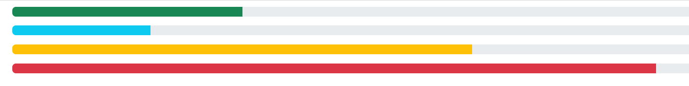

**Task 02:** Create the “Pagination” tool of Bootstrap and give the following output.

**Solution:**

**Index.html:**

<nav aria-label="Page navigation example"><ul class="pagination"><li class="page-item"><a class="page-link" href="#">Previous</a></li><li class="page-item"><a class="page-link" href="#">1</a></li><li class="page-item"><a class="page-link" href="#">2</a></li><li class="page-item"><a class="page-link" href="#">3</a></li><li class="page-item"><a class="page-link" href="#">4</a></li><li class="page-item"><a class="page-link" href="#">Next</a></li></ul></nav><nav aria-label="Page navigation example"><ul class="pagination"><li class="page-item"><a class="page-link" href="#" aria-label="Previous"><span aria-hidden="true">&laquo;</span></a></li><li class="page-item"><a class="page-link" href="#">11</a></li><li class="page-item"><a class="page-link" href="#">12</a></li><li class="page-item"><a class="page-link" href="#">13</a></li><li class="page-item"><a class="page-link" href="#" aria-label="Next"><span aria-hidden="true">&raquo;</span></a></li></ul></nav><h3>Centered</h3><nav aria-label="Page navigation example"><ul class="pagination justify-content-center"><li class="page-item"><a class="page-link" href="#" aria-label="Previous"><span aria-hidden="true">&laquo;</span></a></li><li class="page-item"><a class="page-link" href="#">10</a></li><li class="page-item"><a class="page-link" href="#">...</a></li><li class="page-item"><a class="page-link" href="#">20</a></li><li class="page-item"><a class="page-link" href="#" aria-label="Next"><span aria-hidden="true">&raquo;</span></a></li></ul></nav><h3>Pager (Centered by default)</h3><nav aria-label="Page navigation example"><ul class="pagination justify-content-center"><li class="page-item" style="margin-right: 10px;"><a class="page-link" style="border-radius: 20px; border: 1px solid grey;">Previous</a></li><li class="page-item"><a class="page-link" href="#" style="border-radius: 20px; border: 1px solid grey;">Next</a></li></ul></nav>

**Output:**

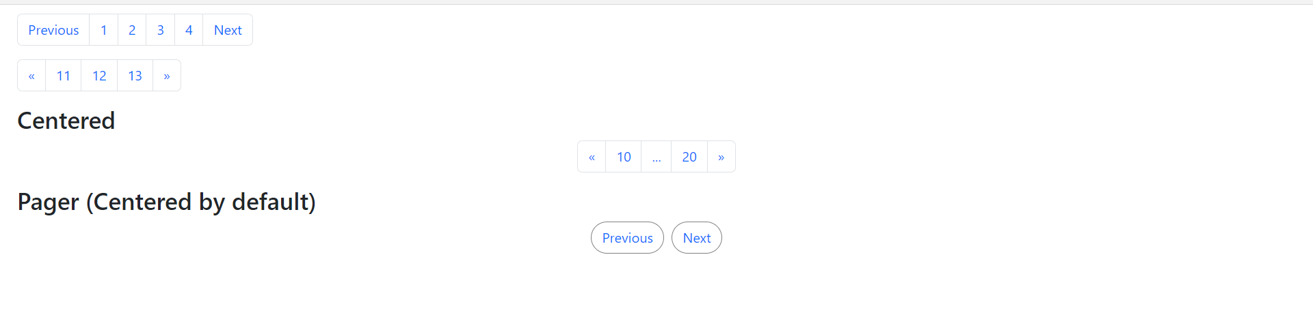

**Task 03:** Use the concept of Alerts in Bootstrap and provide the given output.

**Solution:**

**index.html:**

<div class="container"><div class="alert alert-primary" role="alert">A simple primary alert—check it out!</div><div class="alert alert-secondary" role="alert">A simple secondary alert—check it out!</div><div class="alert alert-success" role="alert">A simple success alert—check it out!</div><div class="alert alert-danger" role="alert">A simple danger alert—check it out!</div></div>

**Output:**

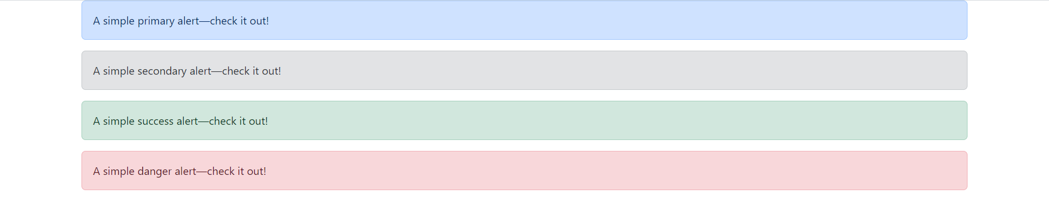

**Task 04:** create a form using bootstrap for designing You can use JS or html validation for validating the form inputs.

**Solution:**

**index.html:**

<link href="https://cdn.jsdelivr.net/npm/bootstrap@5.3.2/dist/css/bootstrap.min.css" rel="stylesheet" integrity="sha384-T3c6CoIi6uLrA9TneNEoa7RxnatzjcDSCmG1MXxSR1GAsXEV/Dwwykc2MPK8M2HN" crossorigin="anonymous"><script src="https://cdn.jsdelivr.net/npm/bootstrap@5.3.2/dist/js/bootstrap.bundle.min.js" integrity="sha384-C6RzsynM9kWDrMNeT87bh95OGNyZPhcTNXj1NW7RuBCsyN/o0jlpcV8Qyq46cDfL" crossorigin="anonymous"></script><div class="container bg-light"><form class="row g-3 needs-validation" novalidate><div class="col-md-12"><label for="validationCustom03" class="form-label">Company Name</label><input type="text" class="form-control" id="validationCustom03" required placeholder="State Life"><div class="invalid-feedback">Please enter your compnay name. This field is required</div></div><div class="col-md-12"><label for="validationCustom03" class="form-label">Phone</label><input type="number" class="form-control" id="validationCustom03" required placeholder="123-456-7890"><div class="invalid-feedback">Please enter a phone # like 123-456-7890. This field is required</div></div> <div class="col-md-12"><label for="validationCustom03" class="form-label">Website</label><input type="text" class="form-control" id="validationCustom03" required placeholder="http://"><div class="invalid-feedback">Please enter your compnay name. This field is required</div></div><div class="col-12"><button class="btn btn-secondary" type="submit">Submit form</button></div></form></div><script>(() => {'use strict'const forms = document.querySelectorAll('.needs-validation')Array.from(forms).forEach(form => {form.addEventListener('submit', event => {if (!form.checkValidity()) {event.preventDefault()event.stopPropagation()}form.classList.add('was-validated')}, false)})})()</script>

**Output:** 